Role bases access control.
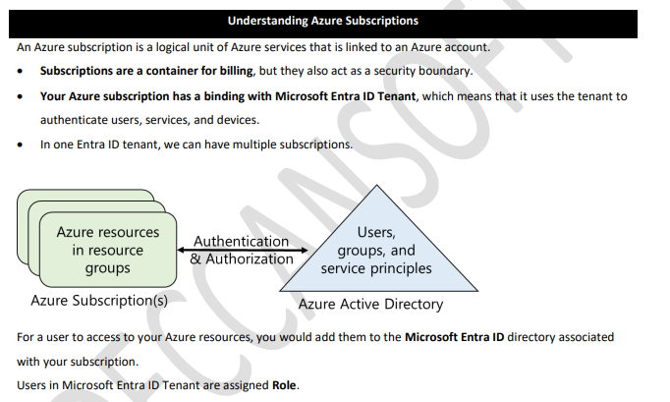

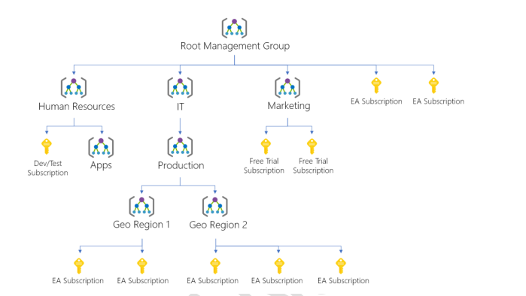

About resources group
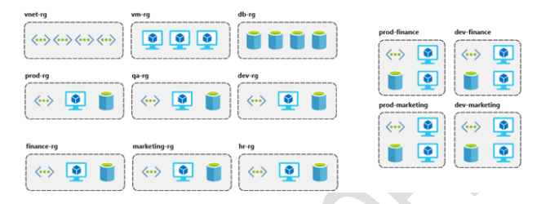
Role base access control (RBAC)
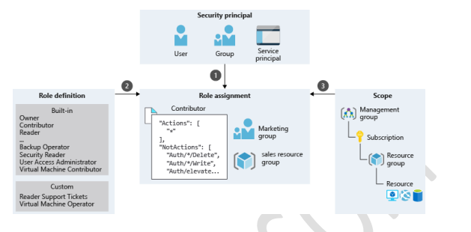
Here is a step-by-step practical guide for Role-Based Access Control (RBAC) in Azure using the Azure Portal (very important for interviews + hands-on).

What is RBAC in Azure?
Role-Based Access Control (RBAC) in Microsoft Azure allows you to control who can access what resources and what actions they can perform.

Real Scenario
You want:
- Admin → Full access
- Developer → Can create resources
- Tester → Read-only access

Step-by-Step Practical (Azure Portal)

Step 1: Login to Azure
- Go to 👉 https://portal.azure.com
- Login with your account

Step 2: Select Resource
RBAC can be applied at:
- Subscription level
- Resource Group level
- Resource level (VM, Storage, etc.)
Example:
- Go to Resource Groups
- Click your resource group (e.g., RG-Demo)

Step 3: Open Access Control (IAM)
- In left menu → Click Access Control (IAM)
- You will see:
  - Role assignments
  - Roles
  - Check access

Step 4: Add Role Assignment
- Click + Add → Add role assignment
- Select Role

Common Roles:
- Owner → Full control
- Contributor → Can create/update
- Reader → Read-only
Example:
Select Contributor

Step 5: Assign to User
- Click Next
- Choose:
  - User / Group / Service Principal
Select:
- Your teammate email (e.g., dev@test.com)
- Click Select

Step 6: Review + Assign
- Click Review + Assign
- Done

Step 7: Verify Access
- Go to Access Control (IAM)
- Click Role assignments
- Confirm user is listed

Step 8: Test Role
Login with that user:
- Contributor → Can create VM
- Reader → Cannot create/delete

Practical Example

Assign Reader Role
- Go to Resource Group
- Add role → Reader
- Assign to Tester
Result:
Tester can only view resources, not modify.

RBAC Levels (Important for Interview)
Level | Description
Management Group | Highest level
Subscription | All resources
Resource Group | Group of resources
Resource | Individual resource

Built-in Roles (Must Know)
- Owner → Full access + assign roles
- Contributor → Full access (no role assign)
- Reader → View only

Using Azure CLI (Important)
# Login
az login

# Assign role
az role assignment create \
--assignee user@email.com \
--role Contributor \
--resource-group RG-Demo

Using Azure PowerShell
Connect-AzAccount

New-AzRoleAssignment `
-SignInName "user@email.com" `
-RoleDefinitionName "Reader" `
-ResourceGroupName "RG-Demo"

Advanced (Interview Level)

Custom Role
- Go to IAM → Roles
- Click + Add custom role
- Define permissions (JSON)

Service Principal (for App)
Used when:
- Your Web API needs access to Azure resources

Principle of Least Privilege
Always give minimum required access

Real Project Flow (Very Important)
In your project:
- Azure App Service → Contributor role
- Azure SQL → Controlled access
- Dev team → Contributor
- QA team → Reader

Interview Tip Answer
“We implemented RBAC in Azure using IAM at resource group level. Developers were assigned Contributor role, testers Reader role, and admin Owner role to ensure secure and controlled access.”

Case Study: Smart Hospital Management System (RBAC in Azure)

Business Scenario
A hospital system is hosted on Microsoft Azure with:
- MVC Frontend (Doctors/Admin UI)
- Web API Backend
- Azure SQL Database

👥 Users & Roles
Role | Access
Admin | Full control
Doctor | Manage patients & appointments
Tester | Read-only
DevOps | Deploy & manage app

Goal
Implement Azure RBAC to:
- Restrict access to resources
- Secure production environment
- Follow least privilege principle

Azure Architecture
- Resource Group → RG-Hospital
- App Service → Web App + API
- Azure SQL Database
- Storage Account (optional logs)

Step-by-Step Practical Implementation

Step 1: Create Resource Group
- Go to Azure Portal
- Click Resource Groups → Create
- Enter:
  - Name: RG-Hospital
  - Region: Central India
- Click Create

Step 2: Create Resources
Create:
- App Service (for MVC + API)
- Azure SQL Database
Example names:
- App: hospital-app
- DB: hospital-db

Step 3: Open RBAC (IAM)
- Go to Resource Group → RG-Hospital
- Click Access Control (IAM)

Step 4: Assign Roles (Core Step)

Assign Admin (Owner Role)
- Click + Add → Add role assignment
- Role → Owner
- Assign to → Admin user email
- Click Assign

Assign Developer (Contributor Role)
- Add role assignment
- Role → Contributor
- Assign to → Developer user
Can deploy app, create resources

Assign Tester (Reader Role)
- Add role assignment
- Role → Reader
- Assign to → Tester
Can only view resources

Assign DevOps (App Service Contributor)
- Role → Contributor OR
Website Contributor
- Assign to DevOps engineer

Step 5: Resource-Level Security (Important)
Instead of full access, restrict:
Example:
- Developer → Contributor on App Service only
- No access to SQL DB

Steps:
- Go to App Service
- IAM → Add role assignment
- Assign Contributor to Developer

Step 6: Secure Database Access
- Go to Azure SQL Server
- Configure:
  - Firewall rules
  - Azure AD Admin
Only Admin can modify DB

Step 7: Verify Access
Login with different users:
Role | Expected Result
Admin | Full access
Developer | Can deploy
Tester | Cannot modify
DevOps | Can manage app

Step 8: Implement Service Access (Advanced)
Your Web API needs DB access:
Use Managed Identity
Steps:
- Go to App Service
- Enable System Assigned Identity
- Go to SQL DB → IAM
- Assign role to App

Azure CLI Implementation (Practical)
# Login
az login

# Assign Contributor to Developer
az role assignment create \
--assignee dev@email.com \
--role Contributor \
--resource-group RG-Hospital

# Assign Reader to Tester
az role assignment create \
--assignee tester@email.com \
--role Reader \
--resource-group RG-Hospital

PowerShell Implementation
Connect-AzAccount

New-AzRoleAssignment `
-SignInName "tester@email.com" `
-RoleDefinitionName "Reader" `
-ResourceGroupName "RG-Hospital"

Advanced RBAC (Interview Level)

Custom Role
Create role:
- Doctor → Only access App Service logs + API
Steps:
- IAM → Roles → Add custom role
- Define permissions (JSON)

Azure AD Integration
Use Azure Active Directory:
- Create groups:
  - AdminGroup
  - DevGroup
  - TesterGroup
- Assign roles to groups (not users)

Best Practices
- Use Resource Group level RBAC
- Use Groups instead of individual users
- Follow Least Privilege
- Avoid giving Owner role unnecessarily

How to Explain in Interview
Note:- “In our hospital project deployed on Azure, we implemented RBAC using IAM. Admins had Owner access, developers were given Contributor role at App Service level, and testers had Reader role. We also restricted database access and used managed identity for secure API communication.”

Advanced Case Study: Enterprise Hospital System (Secure RBAC + JWT)

Goal
- Use Azure Active Directory (Entra ID) for authentication
- Use Azure RBAC for resource-level control
- Use JWT tokens for API security
- Map Azure roles → Application roles

Final Architecture
User (Browser)
↓
Azure AD Login
↓
MVC App (Frontend)
↓ (JWT Token)
Web API (Secure)
↓
EF Core
↓
Azure SQL Database

STEP 1: Register Application in Azure AD
- Go to Azure Portal
- Search → App Registrations
- Click New Registration

Enter:
- Name → HospitalApp
- Redirect URI → https://localhost:5001/signin-oidc
Click Register

Output:
- Client ID
- Tenant ID
Save these (very important)

STEP 2: Create App Roles (VERY IMPORTANT)
- Go to your App → App Roles
- Click Create App Role

Create roles:
- Admin
- Doctor
- Tester

Example:
{
"allowedMemberTypes": ["User"],
"displayName": "Doctor",
"id": "unique-guid",
"isEnabled": true,
"value": "Doctor"
}

STEP 3: Assign Users to Roles
- Go to Enterprise Applications
- Select your app
- Click Users and Groups
- Assign:
  - Admin user → Admin role
  - Doctor user → Doctor role

STEP 4: Configure MVC App (Authentication)
Install NuGet:
Microsoft.Identity.Web
Microsoft.Identity.Web.UI

Configure Program.cs
builder.Services.AddAuthentication(OpenIdConnectDefaults.AuthenticationScheme)
.AddMicrosoftIdentityWebApp(builder.Configuration.GetSection("AzureAd"));

Add appsettings.json
"AzureAd": {
"Instance": "https://login.microsoftonline.com/",
"Domain": "yourdomain.onmicrosoft.com",
"TenantId": "your-tenant-id",
"ClientId": "your-client-id",
"CallbackPath": "/signin-oidc"
}

STEP 5: Secure MVC with Roles
[Authorize(Roles = "Admin")]
public IActionResult AdminDashboard()
{
return View();
}

STEP 6: Configure Web API with JWT
Install:
Microsoft.AspNetCore.Authentication.JwtBearer
Microsoft.Identity.Web

Configure API Authentication
builder.Services.AddAuthentication(JwtBearerDefaults.AuthenticationScheme)
.AddMicrosoftIdentityWebApi(builder.Configuration.GetSection("AzureAd"));

Secure API
[Authorize(Roles = "Doctor")]
[HttpGet("patients")]
public IActionResult GetPatients()
{
return Ok();
}

STEP 7: Pass Token from MVC → API
Use HttpClient:
client.DefaultRequestHeaders.Authorization =
new AuthenticationHeaderValue("Bearer", accessToken);

STEP 8: Azure RBAC for Resources
Now apply infra-level security in Microsoft Azure:
Resource | Role
App Service | Contributor (DevOps)
SQL DB | Restricted
Resource Group | Owner (Admin)

STEP 9: Managed Identity (Secure DB Access)
- Go to App Service
- Enable System Assigned Identity
- Go to SQL Server
- Add identity as user
No connection string passwords needed 🔥

STEP 10: Full Security Flow
Layer | Security
Login | Azure AD
UI Access | Role-based (MVC)
API Access | JWT + Roles
Azure Resources | RBAC
Database | Managed Identity

Real Interview Explanation (PRO LEVEL)
Note:-“We implemented enterprise-grade security using Azure AD for authentication and JWT tokens for API authorization. Application roles like Admin and Doctor were defined in Azure AD and enforced in both MVC and Web API. Additionally, Azure RBAC was applied at the resource level, and managed identity was used for secure database access without credentials.”

Advanced Concepts (Must Know)

Difference:
- RBAC → Azure resource access
- App Roles → Application-level authorization

Token Contains:
- User info
- Roles
- Claims

Best Practice
- Never store secrets
- Use Managed Identity
- Use Role-based authorization everywhere

